Connect Four Acceptance Testcases

San Marcos 3

*Jacob Hopkins, Andrew Kelly, Anne Leach, Daniel Lopez*

For this project three main acceptance testcases were put forward:

1. The game must contain a player vs computer game mode
2. The game must contain a player vs player game mode
3. The game must know when a win condition is present and end the game accordingly

1. Player vs Computer Mode

From the main menu the user can select “Single Player,” choose settings for a single player game, then begin a single player game, which will start a single player game against the computer. The UI elements are shown below.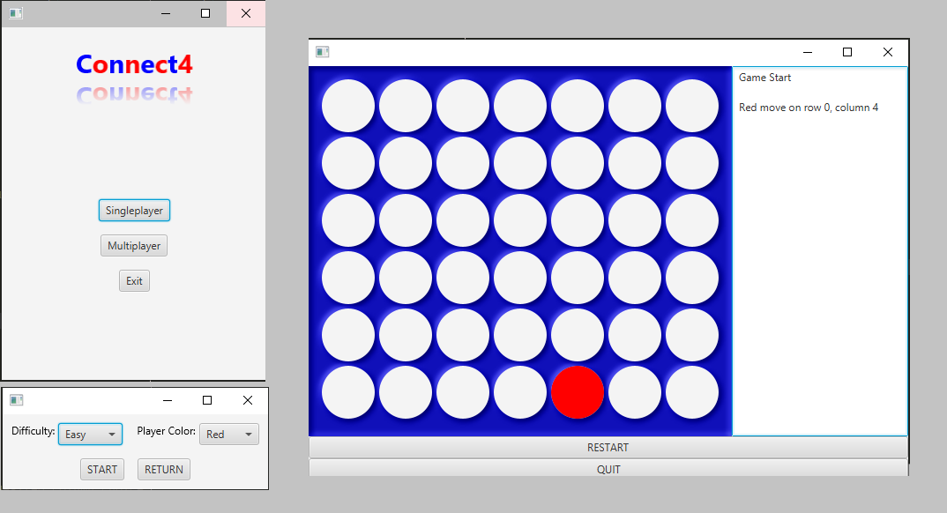

2. Player vs Player mode

From the main menu, the user can select “Multi Player,” choose settings for a multiplayer game, and then begin a multiplayer game. The UI elements are shown below.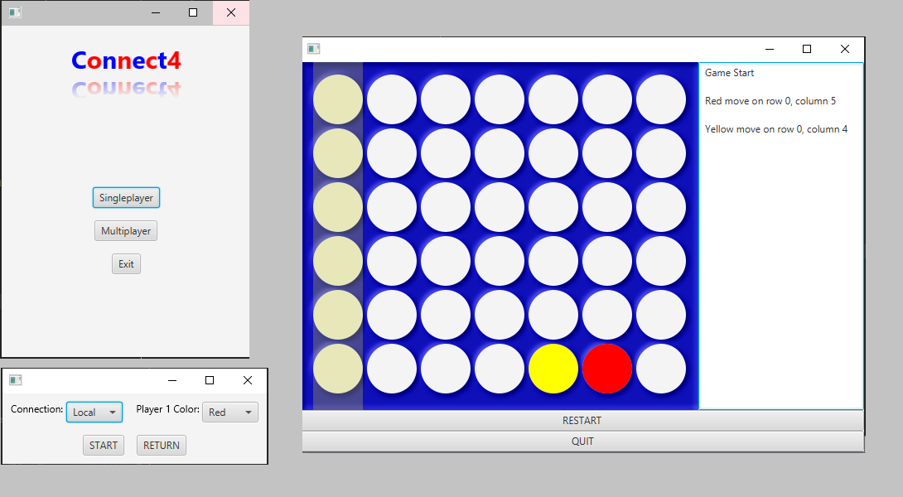

3. Game Over Condition

The program must determine when a game has been won by either player. This can be demonstrated by winning a game either in single player or multiplayer. The game end screen is shown below.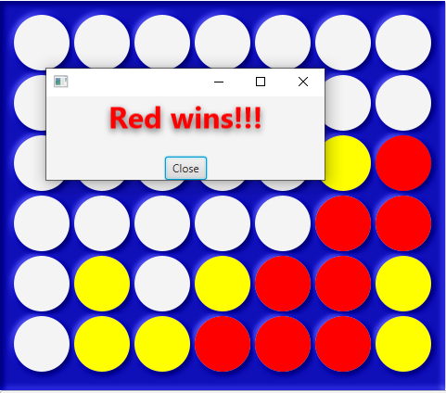

As shown, all three cases have been satisfied by the current program, and thus the program is ready to be shipped to the customer.